…………………………………………………………………………………………………………………………………………………………………

**Install/Setup SBT to work in Scala projects**

I’m following nice and simple guide at <http://www.scala-sbt.org/0.13/docs/Setup.html>

1. Download the zip file from <http://www.scala-sbt.org/0.13/docs/Installing-sbt-on-Windows.html> (I’ve addedd the zip for convenience)
2. Expand it. (I’ve expanded under C:\MyWork\SBT\)
3. Update the PATH in environment varaible with SBT bin folder

Example: PATH=C:\ProgramData\Oracle\Java\javapath;C:\Ruby23-x64\bin;%JAVA_HOME%\bin;C:\MyWork\SBT\sbt\bin;

1. Once setup is complete. Check the version of sbt you just setup by running the command ***Sbt sbtVersion*** (example excreen below)

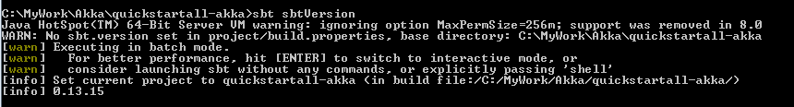

…………………………………………………………………………………………………………………………………………………………………

**Eclipse setup for SBT projects:**

1. Run command ***sbt eclipse*** in a command window

If sbteclipse-plugin is not added you will get error message like below

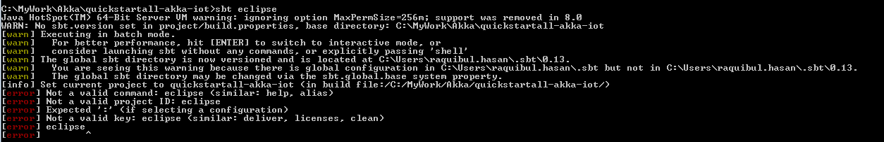

1. You need to add sbteclipse-plugin. I followed the below link to install the plugin

<https://stackoverflow.com/questions/24687698/how-to-use-sbt-eclipse-to-create-eclipse-project-files-of-a-project>

**Steps to install plugin:**

* 1. create plugin folder under the SBT root folder (in my case: **C:\Users\raquibul.hasan\.sbt\0.13)**
  2. Add file **plugin.sbt** with following content

*addSbtPlugin("com.typesafe.sbteclipse" % "sbteclipse-plugin" % "5.1.0")*

At this point your SBT is ready for eclipse

………………………………………………………………………………………………………………………………………………………..........

**Create Scala (Akka) Project using giter8(g8) template**

1. Create a folder where you want to create the scala akka project (C:\MyWork\Akka\quickstartall-akka-iot)
2. Open command window and go to the above folder



1. Run ***sbt new akka/akka-scala-seed.g8 .*** You will receive message like following

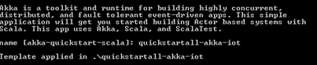

1. In the above step it creates default akka project under **quickstartall-akka-iot**. Go to quickstartall-akka-iot **(C:\MyWork\Akka\quickstartall-akka-iot\quickstartall-akka-iot**). Now, you can quickly test the default created project by running the command **sbt run. Y**ou will see the following messages created by the default project

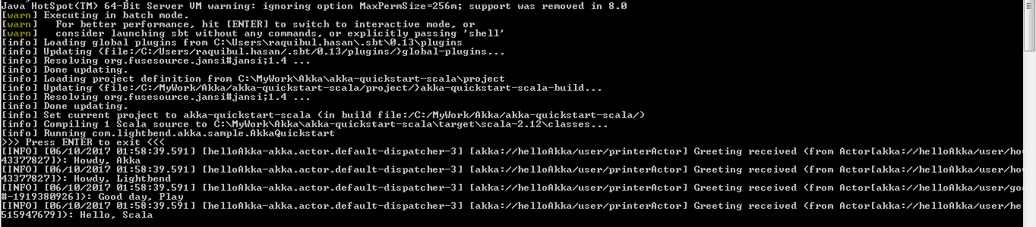

1. Now, import this project to eclipse and start working on you Akka project.
   1. Sbt eclipse
   2. Open Eclipse (I’m using Scala IDE Build id: 4.5.0-vfinal-2016-12-13T10:59:29Z-Typesafe)
   3. Import the project you created above to eclipse : Right click 🡪 Import 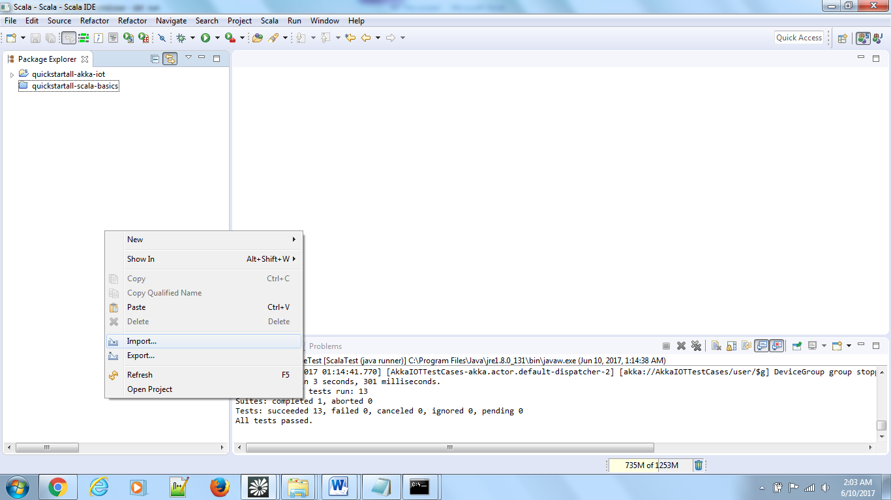
   4. Import 🡪 Existing Projects into workspace
   5. 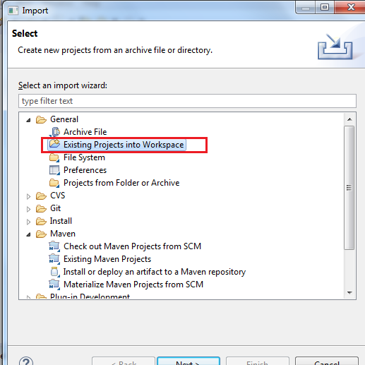
   6. 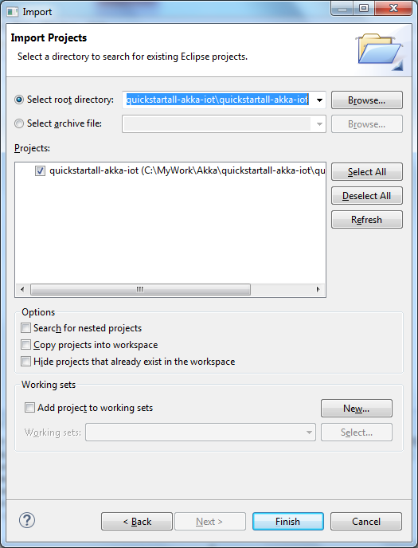
   7. Click on **Finish**
   8. Default project is imported. Now, Go ahead and customize/create your own project.
   9. I’ve created the Akka sample project based on the nice tutorial on Akka website ([***http://doc.akka.io/docs/akka/current/scala/guide/tutorial_1.html***](http://doc.akka.io/docs/akka/current/scala/guide/tutorial_1.html)) which is checked in to my git repo ()